# INTRODUCTION

SVM tries to find out support vectors & margins such that it has maximum separation between the two classes.

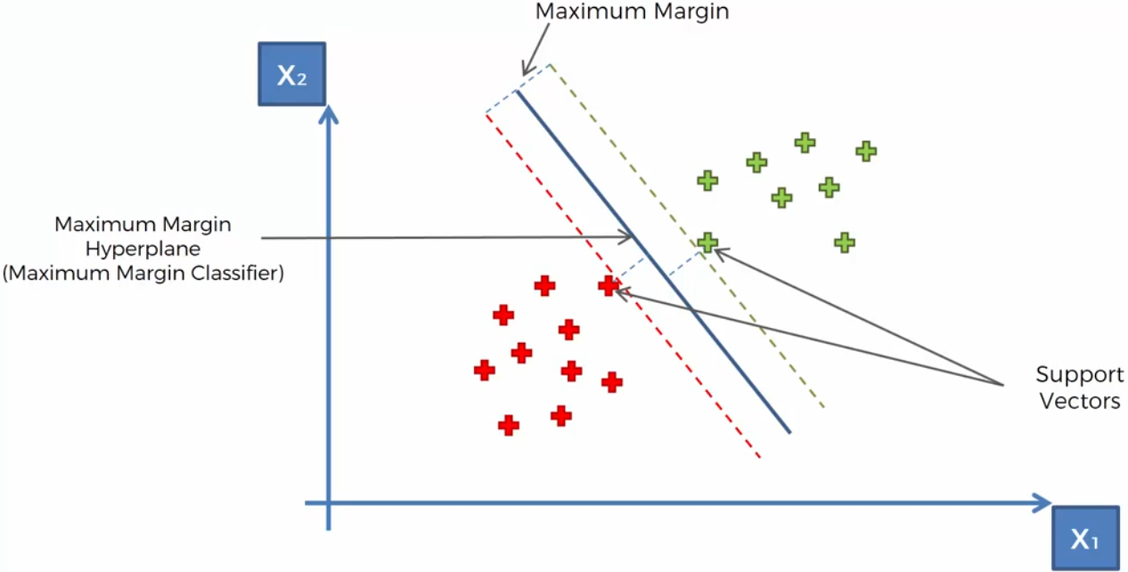

<https://stackoverflow.com/questions/1859554/what-is-entropy-and-information-gain>

# PENALIZED-SVM

During training, we can use the argument class_weight='balanced’ to penalize mistakes on the minority class by an amount proportional to how under-represented it is.

We also want to include the argument probability=True if we want to enable probability estimates for SVM algorithms.

